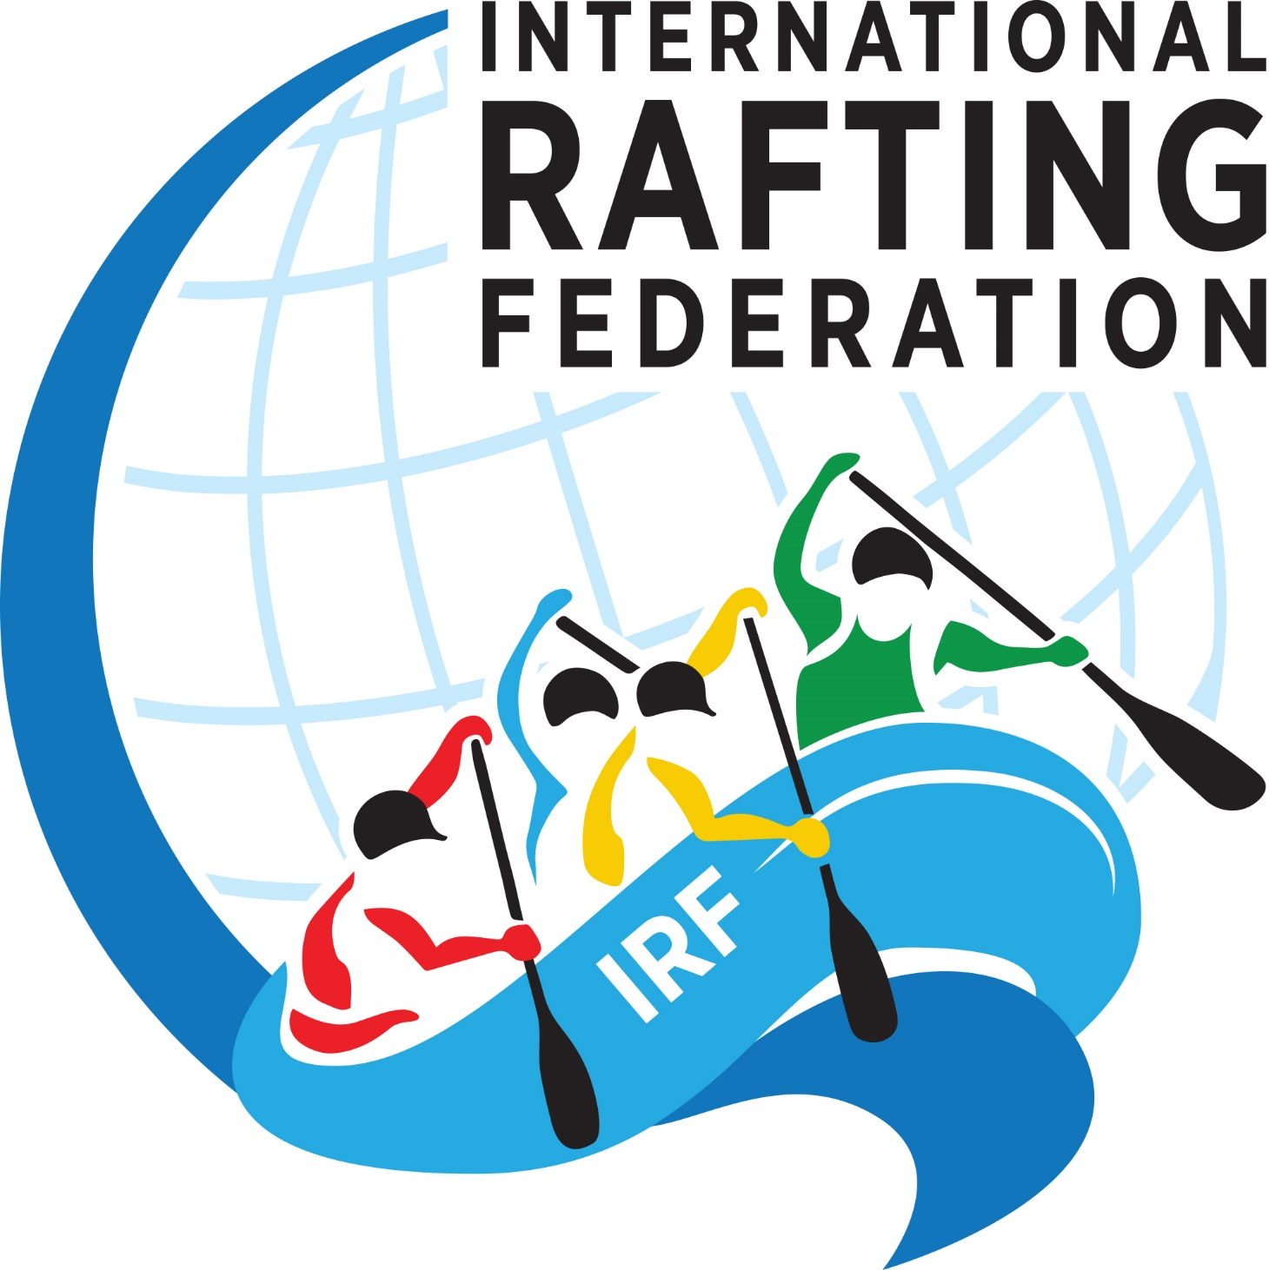

FULL BID DETAILS FOR THE
IRF 20xx Rx WORLD RAFTING CHAMPIONSHIP

Please complete the questionnaire below by answering each question at the bullet point provided underneath each question.
Please send it to the IRF Administration, at info@internationalrafting.com by the 31st December, three years prior to the year of the event (e.g. 31st December 2021 for a WRC in 2024). This bid has to be distributed to the S&C Committee and so must all be in digital format and be a reasonable size. It is preferred that you submit written documentation in .doc, .xls or .pdf format.
It is not important that you use this specific document, as long as your submission includes the details and answers requested here (preferably in the point order set out in this document) and in the ‘World Rafting Championship Regulations and Organising Criteria’ document.

- Principle Details:
  - Name of Country:

  - Dates for event:

  - Name of river /s and area where event is to be held: (please include a map of the area):

  - Nearest town/ city:

  - Has a major rafting event been held in this area before? If yes, please give details.

  - Are you able to run an event at the same time and same place one year before? The event does not need to be of the same scale as the WRC and may be smaller.

  - Are you able to fulfil the requirements of hosting a WRC as described in the ‘World Rafting Championship Regulations and Organising Criteria’ document and the IRF Race Rules?

- Organiser Details
  - Name of Organizer that will be hosting the event:

  - Contact details for the Organizer:

  - Contact person to whom the IRF will communicate with throughout the bid assessment process.

  - Contact person to whom the IRF will communicate with if the bid is accepted. (This is the Event Director or a mutually agreed upon representative)

  - Name of your country’s national rafting federation:

  - Is your federation an up-to-date member of the IRF?

  - If your national rafting federation is not the organisation making the bid, do they support your bid? If yes, please supply a letter of support.

  - Please summarise your qualifications to organize this event. Give examples of other events run and other successful projects completed.

  - List the members of the event organising committee. Please include details of key executives on the Organising Committee, and a full profile of the Event Director, Race Director and Safety Director focussing specifically on raft race organisation experience. If you are needing assistance from the IRF in this respect, please make a note of this here.
- Event Director:
- Race Director:
- Safety Director:
- Local Organising Committee Lead:
  - Please list who in your organisation has been to an IRF WRC before, which event(s) it was and in what way they participated. (spectator, competitor, judge, etc)

- Description of River:
  - Provide a map of the river(s) with GPS coordinates and indicate the individual race venues, entry and exit points, spectator points, nearby roads, etc. If this location has been used for an IRF event before, GPS coordinates are not required.

  - Describe the type, volume and grade of the proposed river(s): (e.g. pool drop, high volume, grade 4-5).

  - What controls the water volume of the river(s)? I.e. is it dam controlled, reliant on seasonal rain, snow melt, etc. If dam controlled, can you provide a guarantee of a suitable water release for the event and pre event training?

  - If there are unexpected high or low water levels – what alternatives can you offer?

  - What is the water and air temperature at the proposed time of running the event? Please detail the suggested paddling gear needed.

  - Describe accessibility at entry and exit points, as well as along the sections of the river where the races are to be run.

  - Describe the type of terrain surrounding each venue: (e.g. steep sided, flat, open fields, jungle, etc, etc)

  - What permissions are needed to host the described event and from whom must they be obtained? (e.g. government, parks, water authority, private land owner, hydroelectric company, etc)?

  - Please provide a detailed description of the safety team and how it will be organised and assigned during the event. (A complete safety plan must be submitted 6 months prior to the WRC).

  - Describe what equipment you propose to use for setting up the slalom gates as well as finish and start lines for each event.

  - How easy or difficult is it for spectators and media to watch the event?

- Races
  - Describe each disciplines’ white water (e.g. Sprint over one class V rapid or over continuous Class III with one class IV rapid in it, Downriver has ten class III’s, five class IV’s, etc) and provide photographs and video of the proposed sections. If the Youth and Junior sections differ to the Open and Masters please detail these. (Youth and Junior are not allowed to run above Class 3 unless an exception is requested and approved.)

  - Give the exact location and details of the race venues for Sprint, Head to Head, Slalom and Downriver.

  - Describe the metric distance of each race venue and the time it would take an average competitive team to complete each discipline.

  - An IRF approved Electronic timing and scoring system is needed. The cost of this is for the organiser, which includes the costs of the trained personnel needed to run it (usually 3 persons). The IRF has a list of approved systems and a list of requirements. If you have a system you wish to use that is not on our list it will need to be seen in action at an event so it can be approved. Do you have your own system? Or will you use one of the IRF approved ones?

- Travel and Transport
  - What is the nearest international airport?

  - What are the best ways for teams to get to the event location from the closest international airport (describe distances and time by road, rail, air, etc)? Please include costs at the time of bid.

  - What are the options and costs for teams, staff and media to get to and from their places of accommodation or from the event headquarters to the race sites?

  - What are the options and costs for spectators?

- Teams:
  - Do you have a maximum number of teams that you can host at the event and if so, what is that number?

  - What is the maximum amount of entry fee you will ask from the teams?

  - What is included in this entry fee? Accommodation fees must be quoted separately to entry fees.

  - Team’s key support personnel (managers, coaches, extra team members) - what is the maximum amount of entry fee you will ask from them and what is included in this fee?

  - What are the costs and options available for teams to train before the event?

  - Can teams from most countries obtain visas to visit your country? Can you offer assistance to those that struggle to get a visa?

- Accommodation Options:
  - What are the various accommodation options available for the teams? Please describe in detail with costs and include brochures and/or website links:

  - Are there any extra items you will be able to cover for the teams (e.g. cash for airfares, accommodation, meals, gear, transport, prize money, etc.)?

  - Do you have a maximum number of support personnel that teams can bring with them? This may include spectators, their media team, coaches, managers, etc

  - Support personnel will normally want to be included with their teams in accommodation, meals, transport and access to the event locations for the duration of the event. Do you see any problems with this?

- Meals:
  - What breakfast options are available for the participants?

  - What lunch options are available for the participants while at the race site, and away from the race site?

  - What dinner options are available for the participants?

  - Are the costs for any meals included in the entry fee?

- Ceremonies and Entertainment
  - What are your plans as far as a) Opening Ceremony, b) Closing Ceremony and c) Daily Medal Ceremonies?

  - Will you be offering evening entertainment to the participants? If yes, what?

  - What else is on offer for participants to enjoy - typical and contemporary?

- Staff/ Officials Provisions
  - Do you understand that you will be covering flights, accommodation, meals and local transport costs for the 3 IRF appointed Jury members?

  - Do you understand that you will be covering accommodation, meals and local transport costs for the 12 IRF appointed Official Judges?

And are you able to provide anything towards the flights for any of these Official Judges?

  - Do you understand that you will be covering accommodation, meals and local transport costs and costs to get them to the location for the IRF Safety Representative (needed if your Safety Director is not an IRF GTE Assessor)?

  - Do you understand that you will be covering accommodation, meals and local transport costs for the IRF President, and IRF Secretary General?

Are you able to contribute anything towards their flights to and from the event location?

  - An IRF approved Race Director is needed so as to ensure the race runs according to IRF standards and Race Rules. If no local person is experienced enough to take on this task then you will need to cover the costs to bring this person in. Do you understand this requirement?

  - Describe the accommodation, meals, transport and working conditions that will be provided for the IRF officials as listed above.

  - Do you anticipate that you will be able to provide all of the staff needed for the event (e.g. safety kayakers / rafters, Safety Director, Race Director, Event Director, etc)? Would you like IRF assistance in finding these persons to assist you?

- Event and media headquarters
  - Describe the event headquarters and their facilities and how close they are to the race courses, and to the officials’ accommodation location.

  - Describe the provisions for Jury meetings, Judges Meetings, Judges Workshops, captains meetings, media meetings, Congress meetings (if being held), etc.

- Rafts
  - What is the minimum number of rafts you would need? (Please read the recommendations in the WRC Reg and Org Criteria document.)

  - Do you have access to enough rafts that fit the IRF requirements as set out in the IRF Race Rules? If not - will you need IRF assistance to get these rafts?

  - What rafts will you be using (make, size, weight, number thwarts, foot cups, etc)? Please provide a link to the manufacturer’s website.

  - Where will you be obtaining them from?

  - How many will you have?

- Logistics and Operations
  - What is the distance and time involved in getting rafts and teams from the exit point back to the start point of the slalom and H2H for their subsequent runs?

  - How do you plan to do this?

  - Do you have enough rafts to run the Downriver for an entire category (eg Open Men) at a time? If not, how long is the turnaround time to get rafts from the Downriver finish back to the start? How will this be done?

  - What system will be used to move the actual paper Judges Slalom penalty sheets from each Judge to the Scorers? (Kayaker, runner, other?)

- Communications
  - What communication systems are you using on the river to run the judging, scoring/ timing, safety and operations? Usually radios are used.

  - Is there mobile phone access at the river course locations? And at the event headquarters?

  - Will there be Wifi available at the river? If yes, will everyone be able to access it? Or who will it be limited to - officials, media, teams, spectators? If no, is it possible to put it in? (Wifi access is very necessary for good media exposure)

- Media coverage:
  - The IRF have minimum requirements for media coverage which are set out in the WRC Reg and Org Criteria document - are you able to supply/comply with all that is listed? If not, which aspects are you not able to supply/comply with?

  - What provisions will be made for the official media with regard to transport, accommodation, meals and access to functions?

- Finances, Safety & Security:
  - Describe where your sponsorships / financial supports / subsidies / guarantees are coming from?

  - Please provide us with a general budget for the event. IRF Admin can provide a template for this. (An Event Status Report which includes a detailed budget with funding sources and allocations will be required one year before the event )

  - Medical Facilities - describe their availability and situation and how they will be put into action during the event.

  - General Liability Insurance - what is required in your country and costs?

  - Are you able to purchase indemnity insurance coverage for an event cancellation due to force majeure, local political instabilities, late event cancellation (6 months or less), event changes due to low or high water, and funds to reimburse in part or in full, air fare costs and event entry fees already incurred by Teams or officials? The amount of insurance coverage purchased must be approved by the IRF.

  - Please describe the business climate in your country (e.g. volatile, secure).

  - Is there any planned election or change of government in the area between now and the event?

  - What is the political stability in your country like? If there is instability (possibilities of terrorism, etc), please describe it as well as what will be done to ensure the safety and security of all participants.

  - A non-refundable hosting fee of $7000 is to be paid to the IRF within 2 weeks of the IRF letting you know you have won the bid. Are you able to pay this fee?

  - A deposit of US$10,000 is to be paid to the IRF in two instalments. First is to be 1 year before the event and the second 6 months before the event. If the event is cancelled less than a year ahead of the event, or if there are any problems with the event not equalling the accepted bid proposal, these funds may be used to correct these problems. Are you able to pay these deposits?

- Doping samples:
Dope testing at the IRF’s A and B level events are compulsory. The organisation and costs for this are to be borne by the organisers.
  - The number of athletes who need to be tested is minimum 15. The time schedule for testing will be set up with the IRF, as well as the communication strategy in relation to the athletes, coaches, media and the competition in general. You, as organisers are responsible for the economic costs, agreements with your country’s Anti-Doping Authority or another approved Doping Authority, and the logistics around managing these test. Are you able to comply with all these requirements?

- Scouting Trip:
  - A scouting trip will be needed if an IRF event is not run regularly or recently at this location or if the organisers do not run events regularly. If the IRF decides a scouting trip is needed – what are you able to provide for the persons doing the scouting trip as far as flights, accommodation, meals, transport and a tour of the event location and organisation?

  - How does the water level at the time of the scouting trip differ to the time of the proposed event?

- Itinerary: List a draft daily itinerary for the event. Keep in mind that the IRF wishes to keep its events as short as possible as longer events are more costly and harder for officials and teams to secure the time.

- Assistance: What areas do you need assistance from the IRF in ensuring the event runs to the high standard expected by the IRF (organisation, equipment, funding, etc)?

- Your proposal: In a few lines tell us why you think the IRF WRC is particularly well-suited to your country?

- Letters of support:
  - If possible, please supply a letter from your government / government sporting body / governing tourism body supporting your bid for the event;
  - Please supply any other letters of support from sponsors, tourist organisations, etc that you feel may help.

- Visuals: Please include photos, maps, brochures, videos and other information to support your proposal.

- Other: Please include any other information you feel is relevant to the bid.

-------- END OF DOCUMENT --------

