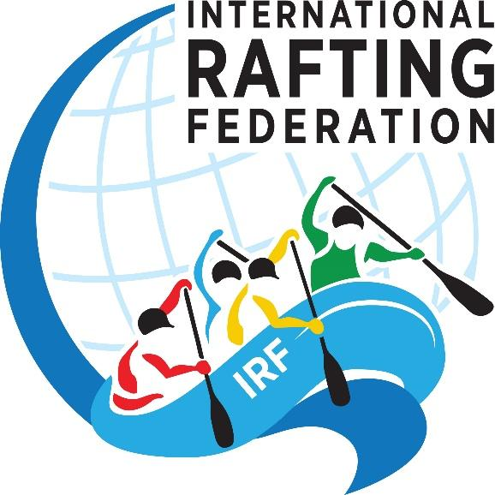
INTERNATIONAL RAFTING FEDERATION
TEMPLATE RAFTING CONSTITUTION

Version 1.3

Guidance
This template may be used for organisations who are forming a new rafting. Change or remove sections so that the constitution is a good fit for the new organisation - this template is a guideline only. Red text are sections which must be completed in order to be compliant with IRF Bylaw requirements.

The key sections that the IRF will be looking for in your Statutes / By-laws / Constitution are:
- That your organisation is democratic in how it runs and how its officers are appointed
- That the members can be any one person or organisation or company that has an interest in furthering the objectives of the organisation
- That there is equality between all the members, all the athletes, all types of rafters and officials, without racial, political, religious, or other discrimination
- That fair and credible national selections are run according to IRF Race Rules
- That they select teams for Continental and World Champs according to IRF Race Rules
- That they work towards having all their guides certified on the IRF GT&E scheme
- That they encourage recreational rafting
- That they promote conservation and environmental protection of river environments

_________________________________________________

CONSTITUTION OF NAME OF ORGANISATION
- NAME
The name of the organisation shall be (Full name and abbreviation, name and abbreviation in your own language if necessary) and is a national, non-profit organisation for all rafters in (country name).
- PRINCIPLES
  - There shall be equality between all the members, all the athletes, all types of rafters and officials, without racial, political, religious, or other discrimination.
  - As a non-profit organisation, the financial resources shall be used only to pursue the purposes set forth in these Bylaws.
- OBJECTIVES
  - Facilitate the growing needs and demands of the rafting fraternity through a unified body that deals with rafting issues and factors that influence the development of rafting.
  - Promote rafting throughout the country by encouraging all guides, recreational rafters and operators to become members
  - Represent and defend the interests of rafting before all national and international authorities.
  - Act as an advisory resource to the media, educational institutions, government agencies, and the general public on rafting issues.
  - Recommend raft guiding and river rescue services, standards and training programs.
  - Work with rafting tour operators and their associations to help safeguard the rafting industry.
  - Work towards having all the country’s river guides on the IRF Guide Training and Education Scheme which includes river rescue services, standards and training programs.
  - Encourage the development of recreational rafting as a contribution to a healthy lifestyle for all ages and abilities.
  - Educate the public in the prevention of damage to the environment as well as promote conservation and environmental protection of river environments.
  - Promote sportsmanship and fair play as well as to encourage friendship between all members of the rafting Fraternity
  - Organise fair and credible national rafting championships according to the IRF Race Rules
  - To select teams for World Champs and European Champs according to IRF Race Rules
  - Promote rafting as an Olympic sport and as a Paralympic sport. The organisation shall observe the general and fundamental principles of the Olympic Charter, the IOC manual on sport and the environment and no provision of these ByLaws shall be deemed to conflict with or derogate from those principles.
  - Train and qualify judges for all sanctioned races.

- MEMBERSHIP
  - The members can be any one person or organisation or company that has an interest in furthering the objectives (as described above) of the (name).
  - Members can apply to (name) to join.
  - Refusal of membership will be very rare and only for persons who will have a negative effect on the organisation’s objectives. The refused person can question the fairness of this refusal through the IRF.
  - Membership fee is (XXX)
  - Renewal of the membership is annually and anyone not renewing their membership by the month of January each year will no longer be a member.
  - If a potential member or members feel that the (name) is acting unfairly or out of line of their objectives, they have the right to question this through the International Rafting Federation.

- STRUCTURES AND DECISION MAKING
  - Annual General Meeting (AGM) will be held once a year.
    - Notices, together with a written agenda, must be given at least 3 weeks before an AGM.
    - A Quorum for an AGM and for general meetings shall mean that at least 50 percent or half of the general membership are present.
    - At the AGM:
      - a new Executive Committee will be voted in
      - projects for the coming year will be approved
      - financial statements for the past year will be approved
      - the appointment of permanent staff will be approved
      - changes or amendments to the constitution or operational procedures will be made
  - General Meetings can be called by the Executive Committee when necessary. The same AGM points will apply (5.1.3.a. to 4.1.c.v.) other than point 5.1.3.a.
  - Executive Committee Meetings will be held at least four times a year. However, the Executive Committee can decide to call additional meetings where necessary.
    - A quorum for Executive Committee meetings shall be at least 50 percent or half of the Executive Committee members.
    - The Executive Committee shall be made up of:
Chairperson
Vice-Chairperson
Secretary
Treasurer
Two-additional Executive Committee members
    - The powers and duties of the Executive Committee shall be
      - To admit or refuse membership, with the understanding that a member may appeal to a general meeting should their application be refused by the Executive Committee, and they may also approach the IRF if they feel the refusal lacks substance.
      - To set up sub-committees where necessary and to allocate clear tasks to it, as well as a time-limit by which it must report back to the Executive Committee on its progress.
      - To plan the activities of the organisation in accordance with the (name)’s Objectives and in consultation with general meetings of members.
      - To ensure that discipline is carried out
      - To resolve any conflict within the organisation
      - To appoint or dismiss full-time staff
      - To administer the finances of the organisation
      - To fill vacancies of office bearers between AGMs where such vacancies occur.
      - To work with the IRF and ensure membership criteria for the IRF are met.
  - Management Committees: (define these if needed as well as national, regional and local structures)
(Depending on the needs of individual organisations the following can be added and expanded here if needed.)

- MEETING PROCEDURE
  - The Chairperson shall chair all meetings, or in his or her absence, this shall be done by the Vice-Chairperson. Where both are absent, the meeting shall elect a Chairperson to chair the meeting.
  - Meetings must be run according to the agenda. No additional issues shall be discussed unless the meeting so decides.
  - Voting will take place by a show of hands unless otherwise decided.
  - Where there are an equal number of votes, the Chairperson shall have a second or casting vote.
  - Minutes of meetings shall be recorded. The meeting’s minutes must be approved by two members who were present at the meeting and then approved of by the Chairperson and Vice Chairperson and should be done within two weeks of the meeting.

- ELECTION OF OFFICE-BEARERS
  - Office-bearers serving on the Executive Committee shall be elected at every AGM. Office-bearers will hold office for a period of 1 year. Where vacancies occur between AGMs, elections can take place at general meetings.
  - The Chairperson shall indicate which position is being voted on and candidates shall be nominated and seconded by members present. Voting shall then take place by a show of hands or if decided on by the meeting, by ballot papers.
  - The Chairperson will announce the result after each vote. If there is only one person nominated for a position, the Chairperson shall announce that that person has been elected unopposed. Where there is no nomination for a position, a fresh election for that particular position shall be held at a forthcoming general meeting.

- STAFF
(If the organisation employs full time staff the following must be defined here: How they are appointed; what positions they hold, what their duties are to whom they are accountable.)

- DISCIPLINE
  - The Executive Committee has the right to investigate the actions or attitude of any members who may have acted against the objectives of the organisation. However, a member must also be given notice of a disciplinary hearing and must have the right to appeal against the outcome of the hearing.
  - Based on its investigation, the Executive Committee can decide, by a two-thirds majority to expel or to temporarily suspend a member.

- FINANCIAL CONTROL
  - The Treasurer will be responsible for handling the accounts of the organisation. This includes keeping the Executive Committee informed at all times of deposits and withdrawals made and for what purposes, as well as issuing receipts, following up on unpaid memberships and depositing the same into the account.
  - All funds received for the organisation shall be deposited into the organisation’s account within 1 week.
  - The Treasurer shall be responsible for producing financial reports at the AGM and at other times required by the Executive Committee.
  - The Treasurer, Secretary and Chairperson shall be the only signatories.
  - The organisation financial year shall be from 01 January to 31 December.

- AFFILIATION
(If the organisation wishes to be affiliated to any other organisation it should include:
The name is an affiliate of the name of other organisation and accordingly agrees to abide by their rules and regulations and to work together with other affiliates to strengthen their and the name’s objectives.)

- AMENDMENTS TO THE CONSTITUTION
  - The Constitution can only be amended by a two-thirds majority of an Executive Committee meeting or general meeting.
  - Any member wishing to propose an amendment must inform the Secretary in writing of the proposed amendment so that the item can be placed on the agenda of a general meeting.

- DISSOLUTION
  - The Executive Committee must recommend the dissolution of the organisation to a general meeting. At least Three quarters of a representative general meeting must vote in favour of dissolving the organisation.
  - Should such a decision be taken, the organisation shall appoint a liquidator to wind up the affairs of the organisation. The assets and remaining funds shall be distributed according to a decision made by the general meeting.

