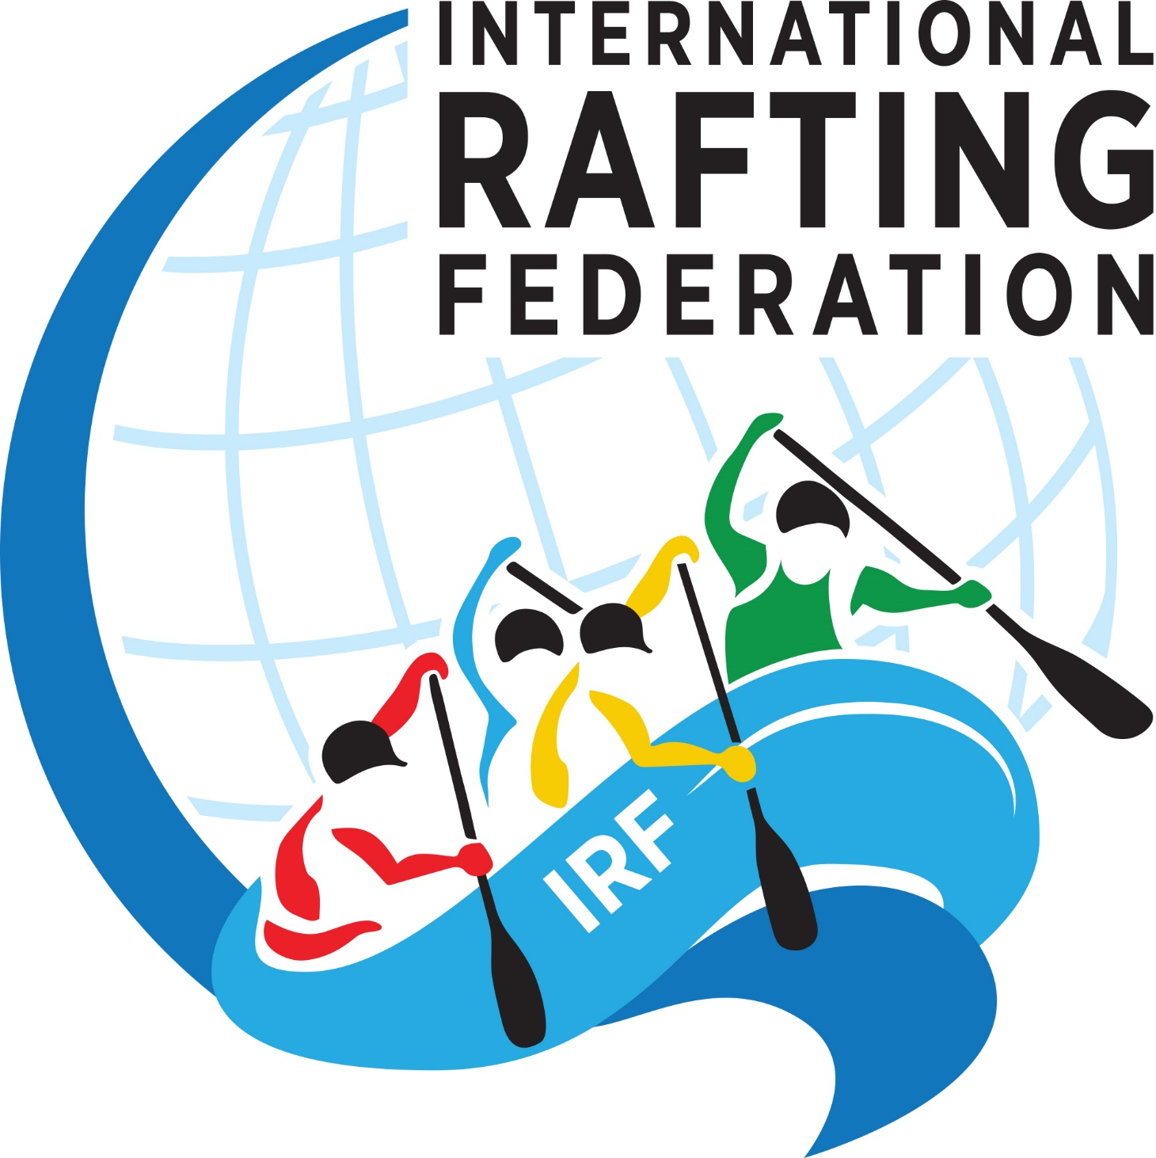

INTENTION TO BID

Event bidding for:
Country:
Name of Member Federation:
Number of years as a member of the IRF:
Name of organisation that will run the event:
Dates proposing for the event:
River/s and section for:
- Sprint:
- H2H:
- Slalom:
- Downriver:
Location where event will be based out of:
Please detail the political stability and safety in your country:

Please detail all raft races run according to the IRF Race Rules that your federation has run in the last 5 years - for each event list the following: dates, number of teams that attended, any teams from other countries - name countries, name of Head Judge, and names of IRF representatives at the event.
Event | # teams | International teams | Judges / IRF

Please detail the experience of the organisation to run such an event:

-------- END OF DOCUMENT --------

